Public Data, Private Conclusions -
The Art of Open Source Intelligence

Professional Intelligence Report

🌐 TARGET WEBSITE

🌐 https://www.chicken-road2.app/

📄 Project Type | Open Source Intelligence (OSINT)
🔍Investigation Method | Passive Intelligence Gathering
🌐Target Domain | chicken-road2.app
🗓️Submission Date | 28 July 2026

CYBERSECURITY INTERNSHIP PROGRAM

TABLE OF CONTENTS

Section | Page No
Executive Summary | 4
Target Overview | 5
Website Investigation  3.1 Domain Information  3.2 WHOIS Details  3.3 IP Address Information  3.4 DNS Records  3.5 Hosting Provider  3.6 SSL Certificate Information  3.7 Security Header  3.8 Technologies Used  3.9 Subdomains  3.10 robots.txt  3.11 sitemap.xml  3.12 Other Public Information | 6
Source Documentation | 19
Intelligence Analysis | 20
Recommendations | 24
References | 24
Appendix | 26

1.Executive Summary

This report presents the findings of a passive Open Source Intelligence (OSINT) investigation conducted on the target website https://www.chicken-road2.app/. The objective of the investigation was to gather publicly available information related to the website's infrastructure, domain registration, DNS configuration, hosting environment, SSL/TLS implementation, security headers, technologies used, and other accessible
resources.
The investigation was performed using trusted OSINT tools and publicly available sources without interacting with or affecting the target system. The collected information indicates that the website utilizes modern web technologies and Cloudflare services for DNS management and content delivery.
Overall, the investigation demonstrates how publicly available information can provide valuable insights into a target's online infrastructure while highlighting the importance of implementing security best practices to strengthen the website's overall security posture.

2.Target Overview

2.1 Investigation Objective

The objective of this investigation was to perform an Open Source Investigation (OSINT) assessment on the target website (https://www.chicken-road2.app/) using only publicly available information. The investigation aimed to gather relevant intelligence about the target’s online presence, infrastructure, technologies, security posture, and publicly exposed information without interacting with or affecting the target system.

2.2 Investigation Scope

Scope
This investigation was limited to passive information gathering techniques. Only publicly accessible information obtained through trusted OSINT tools and websites was used. No vulnerability exploitation, authentication bypass, scanning that could impact the target, or unauthorized access attempts were performed during the investigation.

2.3 Target Details

FIELD | VALUE
Target Website | https://www.chicken-road2.app/
Target Domain | chicken-road2.app
Top-Level Domain | .app
Protocol | HTTPS
Investigation Type | Passive Open Source Intelligence (OSINT)
Investigation Method | Publicly Available Information Gathering
Target Status | Publicly Accessible Website

2.4 Investigation Methodology

Methodology
The investigation followed a structured passive OSINT approach by collecting publicly available information from multiple trusted sources. The collected data included domain registration details, DNS records, IP address information, hosting provider details, SSL certificate information, security headers, technologies used, publicly available subdomains, robots.txt, sitemap.xml, and other accessible information. Each finding was documented together with the corresponding source and tool used to ensure traceability and reliability.

3. Website Investigation

3.1 Domain Information

Overview
Domain Information provides the basic identification details of a website, including its domain name, top-level domain (TLD), communication protocol, and domain status. It serves as the foundation of an OSINT investigation by establishing the target’s identity before conducting further technical analysis.

Purpose of Investigation
The domain information was examined to:
- Identify the target website and domain.
- Verify the website’s publicly accessible URL.
- Determine the communication protocol used by the website.
- Identify the top-level domain (TLD).
- Establish the basic domain information for further investigation.

Findings

Field | Value
Target Domain | chicken-road2.app
Website URL | https://www.chicken-road2.app/
Top-Level Domain (TLD) | .app
Protocol | HTTPS
Domain Status | clientTransferProhibited

Tools Used : WHOIS
Source URL : https://who.is/ , https://www.whois.com/

3.2 WHOIS Details

Overview
WHOIS is a publicly accessible database that stores domain registration information. It provides details such as the domain registrar, registration and expiration dates, name servers, domain status, and other administrative information. During an OSINT investigation, WHOIS data helps verify the legitimacy and lifecycle of a domain.

Purpose of Investigation
The WHOIS information was examined to:
- Identify the domain registrar.
- Verify the domain registration and expiration dates.
- Determine the domain’s current status.
- Identify the authoritative name servers.
- Understand the domain’s registration history.

Findings

Field | Value
Registrar | Key-Systems LLC
Creation Date | 13 May 2025
Last Updated Date | 04 May 2026
Expiry Date | 13 May 2027
Name Servers | autumn.ns.cloudflare.com , denver.ns.cloudflare.com
Country | GB
Domain Status | Active

Tools Used : WHO.IS RDAP
Source URL : https://who.is/rdap/chicken-road2.app

3.3 IP Address Information

Overview
An IP (Internet Protocol) address is a unique numerical identifier assigned to a device or server connected to the internet. During an OSINT investigation, IP address information helps identify the hosting network, Autonomous System Number (ASN), approximate geolocation, and service provider associated with the target website.

Purpose of Investigation
The IP address information was examined to:
- Identify the public IP address associated with the target domain.
- Determine the hosting network and Autonomous System Number (ASN).
- Identify the hosting provider.
- Obtain publicly available geolocation information.
- Understand the network infrastructure supporting the website.

Findings

Field | Value
IPv4 Address | 104.21.38.193
IPv4 Address | 172.67.137.239
IPv6 Address | 2606:4700:3030::ac43:89ef , 2606:4700:3034::6815:2621
Autonomous System (ASN) | AS13335
ASN Name | Cloudflare, Inc.
Hosting Provider | Cloudflare, Inc.
Network Type | Hosting / CDN
Approximate Location | San Francisco, California, United States

Tools Used : MXToolbox, IPinfo
Source URL : https://mxtoolbox.com/ , https://ipinfo.io/

3.4 DNS Records

Overview
The Domain Name System (DNS) translates a domain name into IP addresses, enabling users to access websites using human-readable names instead of numerical IP addresses. DNS records also provide information about email configuration, domain verification, name servers, and other services associated with a domain.

Purpose of Investigation
The DNS Records were examined to:
- Identify the IP addresses associated with the target domain.
- Verify the configured name servers.
- Identify the email-related DNS records.
- Identify domain verification records.
- Understand the domain’s DNS configuration.

Findings

Record Type | Value
A Record | 104.21.38.193 , 172.67.137.239
AAAA Record | 2606:4700:3030::ac43:89ef , 2606:4700:3034::6815:2621
MX Record | No MX Record Found
NS Record | autumn.ns.cloudflare.com , denver.ns.cloudflare.com
TXT Record | google-site-verification=0wvhA6b5wO4XvHwi25O0BDtvDU1zxYWWnF4yNXsZsFk
CNAME Record | No Record Found

Tools Used : MXToolbox
Source URL : https://mxtoolbox.com

3.5 Hosting Provider

Overview
A hosting provider is the organization responsible for delivering a website’s content and services over the internet. Identifying the host provider helps determine where the website’s traffic is managed and provides insight into the infrastructure supporting the target website.

Purpose of Investigation

The hosting provider was examined to:
- Identify the organization providing network services for the website.
- Determine the hosting infrastructure used by the target.
- Identify the Autonomous System Number (ASN).
- Understand the publicly visible hosting environment.

Findings

Field | Value
Hosting Provider | Cloudflare, Inc.
ASN | AS13335
ASN Type | Hosting
Service Type | Content Delivery Network (CDN) and Reverse Proxy
Network Range | 104.21.32.0/20
Approximate Hosting Location | San Francisco, California, United States

Tools Used : IPinfo
Source URL : https://ipinfo.io/

3.6 SSL Certificate Information

Overview
An SSL/TLS certificate is a digital certificate that encrypts communication between a user’s browser and a website. It authenticates the website’s identity and helps ensure the confidentiality and integrity of data transmitted over the network.

Purpose of Investigation

The SSL certificate information was examined to:
- Verify that the website uses HTTPS encryption.
- Identify the certificate issuer.
- Check the certificate validity period.
- Verify the certificate’s trust status.
- Review publicly available certificate details.

Findings

Field | Value
Common Name (CN) | chicken-road2.app
Alternative Names (SAN) | chicken-road2.app , *.chicken-road2.app
Certificate Issuer | Google Trust Services (WE1)
Signature Algorithm | SHA256withECDSA
Key Type | EC 256-bit
Valid From | 05 July 2026
Valid Until | 03 October 2026
Certificate Transparency | Enabled
Revocation Status | Good (Not Revoked)
Trusted | Yes
Extended Validation (EV) | No

Tools Used : SSL Labs (SSL Server Test)
Source URL : https://www.ssllabs.com/ssltest/

3.7 Security Headers

Overview

HTTP security headers are additional response headers sent by a web server to instruct web browsers on how to securely handle website content. They help protect web applications against common attacks such as Cross-Site Scripting (XSS), clickjacking, MIME-type sniffing, and information leakage.

Purpose of Investigation

The security headers were examined to:
- Identify the HTTP security headers implemented by the website.
- Assess whether recommended security headers are configured.
- Identify missing security headers that could impact the website’s security posture.
- Evaluate the website’s publicly visible security configuration.

Findings

Header | Status
Strict-Transport-Security (HSTS) | Present
Content-Security-Policy | Missing
X-Frame-Options | Missing
X-Content-Type-Options | Missing
Referrer-Policy | Missing
Permissions-Policy | Missing

Tools Used : SecurityHeaders.com
Source URL : https://securityheaders.com/

3.8 Technologies Used

Overview

Identifying the technologies used by a website helps determine the software, frameworks, services, and infrastructure that power the application. This information provides insight into the website’s architecture and publicly visible technology stack.

Purpose of Investigation

The technologies used by the website were examined to:
- Identify the web frameworks and programming technologies.
- Determine the hosting and deployment platform.
- Identify content delivery and performance optimization services.
- Discover publicly visible third-party technologies integrated into the website.

Findings

Technology Category | Technology Identified
Static Site Generator | Next.js (16.1.6)
Web Framework | Next.js (16.1.16)
Web Server | Next.js (16.1.16)
Javascript Framework | React
Platform as a Service | Vercel
Content Delivery Network (CDN) | Cloudflare, Cloudinary, jsDelivr
Performance Optimization | Cloudflare Rocket Loader, Priority Hints
Digital Asset Management | Cloudinary
Analytics / RUM | Cloudflare Browser Insights
Miscellaneous | HTTP/3, Open Graph, Progressive Web App (PWA)

Tools Used : Wappalyzer
Source URL : https://www.wappalyzer.com/

3.9 Subdomains

Overview
Subdomains are subdivisions of a primary domain that are used to organize or provide access to different services or sections of a website.Identifying publicly available subdomains during an OSINT investigation helps understand the target’s exposed infrastructure and discover additional publicly accessible resources.

Purpose of Investigation

The subdomains were examined to:
- Identify publicly accessible subdomains associated with the target domain.
- Discover additional services hosted under the target domain.
- Understand the publicly visible domain structure.
- Identify any additional entry points exposed through DNS records.

Findings

Subdomain | Status / Description
www.chicken-road2.app | Publicly accessible website
Additional Public Subdomains | No additional publicly discoverable subdomains identified during the investigation.

Tools Used : DNSDumpster, crt.sh (Certificate Transparency Logs)
Source URL: https://dnsdumpster.com/ , https://crt.sh/

3.10 robots.txt

Overview

The robots.txt file is a publicly accessible text file located in the root directory of a website. It provides instructions to web crawlers and search engine bots regarding which parts of the website may or may not be accessed for indexing. During an OSINT investigation, the robots.txt file may reveal publicly disclosed directories, restricted paths, and the location of the website’s sitemap.

Purpose of Investigation

The robots.txt file was examined to:
- Identify directories that are restricted from web crawlers.
- Discover publicly available paths and resources.
- Locate the website’s sitemap.
- Understand the website’s crawling and indexing policy.

Findings

Directive | Value
Default User-Agent | * (All web crawlers)
Allowed Path | /
Disallowed Paths | /api/* , /go/* , /pages/condition-utilisation
Blocked Crawlers | AhrefsBot, SemrushBot, DotBot, Screaming Frog SEO Spider, Chatgpt-User
Sitemap Location | https://www.chicken-road2.app/sitemap.xml

Tools Used : Web Browser
Source URL : https://www.chicken-road2.app/robots.txt

3.11 sitemap.xml

Overview

A sitemap.xml file is an XML document that lists the publicly accessible pages of a website. It is primarily used to help search engines discover and index website content efficiently. During an OSINT investigation, a sitemap can provide insight into the website’s publicly exposed pages and overall site structure.

Purpose of Investigation

The sitemap.xml file was examined to:
- Identify publicly accessible web pages.
- Understand the website’s structure.
- Verify that a sitemap is available.
- Identify the last modification date of the published content.

Findings

Field | Value
Sitemap URL | https://www.chicken-road2.app/sitemap.xml
Status | Accessible
Number of URLs Listed | 1
Indexed URL | https://www.chicken-road2.app
Last Modified | 24 July 2026 (2026-07-24T09:08:08:270Z)

Tools Used : Web Browser
Source URL : https://www.chicken-road2.app/sitemap.xml

3.12 Other Publicly Available Information

Overview

In addition to technical information, publicly accessible website resources such as the Terms of Service, Privacy Policy, and contact information can provide valuable intelligence about the website’s operations, transparency, and publicly disclosed information. These resources help build a more complete understanding of the target during an OSINT investigation.

Purpose of Investigation

The publicly available information was examined to:
- Identify legal and policy-related pages.
- Verify the availability of contact information.
- Identify additional publicly disclosed information about the website.
- Complete the passive OSINT investigation using publicly accessible resources.

Findings

Information | Status / Value
Terms of Service | Available
Privacy Policy | Available
Contact Email | contact@www.chicken-road2.app
Website Accessibility | Publicly Accessible
Public Legal Information | Available through the website

Tool Used : Web Browser
Source URL : https://www.chicken-road2.app/

4. Source Documentation

Overview

This section documents the sources used during the OSINT investigation. Each finding is mapped to the corresponding OSINT tool or website along with the exact source URL to ensure transparency, traceability, and verification of the collected information.

Source Documentation Table

Information Collected | Tool / Website Used | Source URL
Domain Information | WHO.IS | https://who.is/
WHOIS Details | WHO.IS (RDAP) | https://who.is/rdap/chicken-road2.app
DNS Record | MXToolbox | https://mxtoolbox.com/
IP Address Information | IPinfo | https://ipinfo.io/
Hosting Provider | IPinfo | https://ipinfo.io/
SSL Certificate Information | SSL Labs | https://www.ssllabs.com/ssltest/
Security Header | SecurityHeaders.com | https://securityheaders.com/
Technologies Used | Wappalyzer | https://www.wappalyzer.com
Subdomains | DNSDumpster | https://dnsdumpster.com/
Certificate Transparency Logs | crt.sh | https://crt.sh/
robots.txt | Web Browser | https://www.chicken-road2.app/sitemap.xml
sitemap.xml | Web Browser | https://www.chicken-road2.app/sitemap.xml
Public Website Information | Web Browser | https://www.chicken-road2.app/

5. Intelligence Analysis

Overview

The collected OSINT data was analyzed to identify potential security observations, assess the target’s publicly visible security posture, and determine whether any publicly available information could introduce security risks. The analysis presented in this section is based solely on information gathering during the passive investigation.

5.1 Domain Registration Status

Finding

The domain is registered with Key-Systems LLC and remains valid until 13 May 2027. The domain status is clientTransferProhibited.

Analysis

The domain is actively maintained and protected against unauthorized registrar transfers through the clientTransferProhibited status. This reduces the risk of domain hijacking through unauthorized transfer requests.

Security Impact

This is considered a positive security practice, as it helps protect the ownership of the domain.

5.2 DNS Configuration

Finding
The domain uses Cloudflare name servers and resolves to two public IPv4 addresses. No MX record was identified, while a TXT record for Google site verification is present.

Analysis
Cloudflare-managed DNS indicates that the website relies on Cloudflare’s infrastructure for DNS resolution. The absence of an MX record suggests that the domain may not currently be configured to receive email. The TXT record appears to be used for domain ownership verification.

Security Impact
The DNS configuration does not expose sensitive information. The lack of an MX record may reduce exposure to email-related attacks if the domain does not provide email services.

5.3 Hosting Infrastructure

Findings
The website is publicly served through Cloudflare (AS13335).

Analysis
Cloudflare acts as a Content Delivery Network (CDN) and reverse proxy, helping protect the origin infrastructure while improving website performance and availability.

Security Impact
Using Cloudflare enhances security by providing protection against threats such as DDoS attacks and by masking the origin server from direct public access.

5.4 SSL/TLS Configuration

Finding
The website uses a trusted SSL/TLS certificate issued by Google Trust Services (WE1).

Analysis
The certificate is valid, trusted, and supports encrypted HTTPS communication between clients and the website.

Security Impact
A valid SSL certificate helps ensure data confidentiality, integrity, and user trust by encrypting network traffic.

5.5 Security Headers

Finding

Several recommended HTTP security headers were not present, including:
- Content-Security-Policy (CSP)
- X-Frame-Options
- X-Content-Type-Options
- Referrer-Policy
- Permissions-Policy

Analysis
These headers provide additional protection against common web-based attacks and improve browser security behavior. Their absence indicates opportunities to strengthen the website’s security configuration.

Security Impact
Missing security headers may increase exposure to attacks such as Cross-Site Scripting (XSS), clickjacking, MIME-type sniffing, and unintended information disclosure.

5.6 Technology Stack

Finding
The website uses Next.js , React , Vercel , Cloudflare , Cloudinary, and jsDelivr.

Analysis
The identified technologies indicate that the website is built using a modern web development stack and leverages cloud-based services for hosting, content delivery, and performance optimization.

Security Impact
Modern frameworks are generally well-supported; however, they should be kept up to date to reduce the risk of vulnerabilities associated with outdated software versions.

5.7 Publicly Accessible Files

Finding
The robots.txt file defines crawler permissions and references the sitemap file. The sitemap contains one publicly indexed URL, suggesting a relatively simple website structure.

Analysis
The robots.txt file defines crawler permissions and references the sitemap.xml file. The sitemap contains one publicly indexed URL , suggesting a relatively simple website structure.

Security Impact
No sensitive directories or confidential resources were exposed through the publicly available robots.txt or sitemap.xml files during the investigation.

6. Recommendations

Overview

Based on the findings obtained during the OSINT investigation, several recommendations can be made to improve the target website's publicly visible security posture. These recommendations are intended to reduce potential security risks and align the website with common security best practices.

6.1 Implement Missing Security Headers
Recommendation:
Configure the missing HTTP security headers, including:
- Content-Security-Policy (CSP)
- X-Frame-Options
- X-Content-Type-Options
- Referrer-Policy
- Permissions-Policy
Reason:
These headers help protect against common web attacks such as Cross-Site Scripting (XSS), clickjacking, MIME-type sniffing, and information leakage.

6.2 Maintain SSL/TLS Certificates
Recommendation:
Continue renewing SSL/TLS certificates before expiration and use trusted Certificate Authorities (CAs).
Reason:
Maintaining valid certificates ensures secure encrypted communication and preserves user trust.

6.3 Regularly Monitor DNS Configuration
Recommendation:
Periodically review DNS records to ensure they remain accurate and remove any unnecessary or outdated records.
Reason:
Proper DNS management reduces the risk of misconfigurations and unintended exposure of services.

6.4 Keep Software and Frameworks Updated
Recommendation:
Regularly update web frameworks, libraries, and third-party services such as Next.js, React, and other supporting technologies.
Reason:
Keeping software up to date helps mitigate known vulnerabilities and improves overall security.

6.5 Perform Regular Security Assessments
Recommendation:
Conduct periodic security reviews, vulnerability assessments, and penetration testing to identify and remediate potential weaknesses.
Reason:
Regular assessments help maintain a strong security posture and identify issues before they can be exploited.

7. References

Tool / Website | URL
WHOIS | https://who.is/
WHO.IS RDAP | https://who.is/rdap/chicken-road2.app
MXToolbox | https://mxtoolbox.com/
IPinfo | https://ipinfo.io/
SSL Labs | https://www.ssllabs.com/ssltest/
SecurityHeaders.com | https://securityheaders.com/
Wappalyzer | https://www.wappalyzer.com/
DNSDumpster | https://dnsdumpster.com/
crt.sh | https://crt.sh/
Target Website | https://www.chicken-road2.app/
robots.txt | https://www.chicken-road2.app/robots.txt
sitemap.xml | https://www.chicken-road2.app/sitemap.xml

APPENDIX

Figure 1 - Domain Information
Screenshot showing the target domain information obtained from WHO.IS
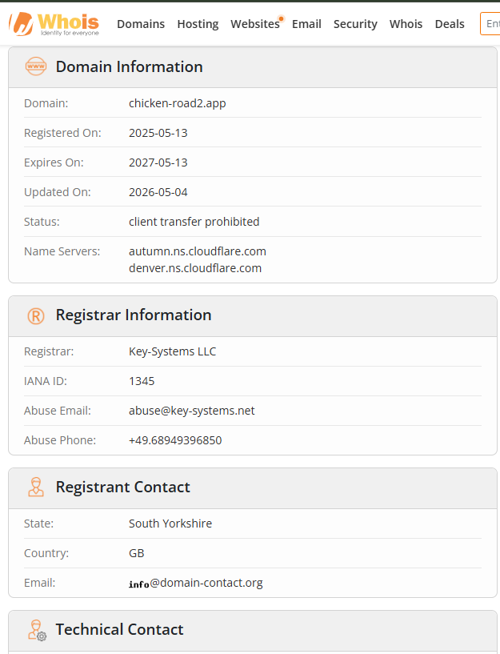
Figure 2 - WHOIS Details
WHOIS / RDAP information showing the registrar, registration dates, expiry date, and name servers.
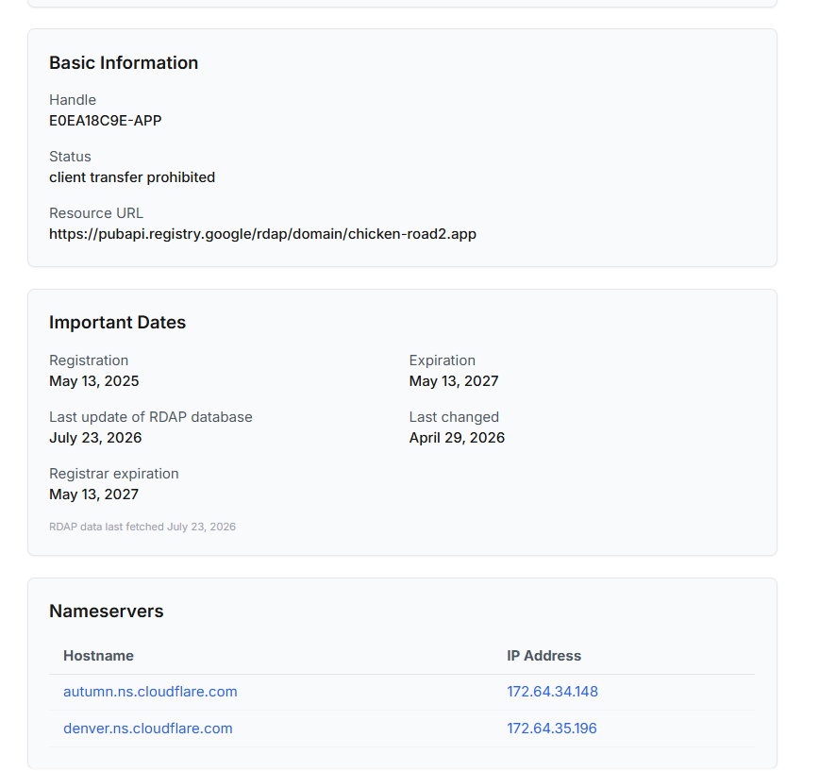
Figure 3 - DNS Records
DNS Records collected from MXToolbox, including A, AAAA, NS, TXT, and MX records.

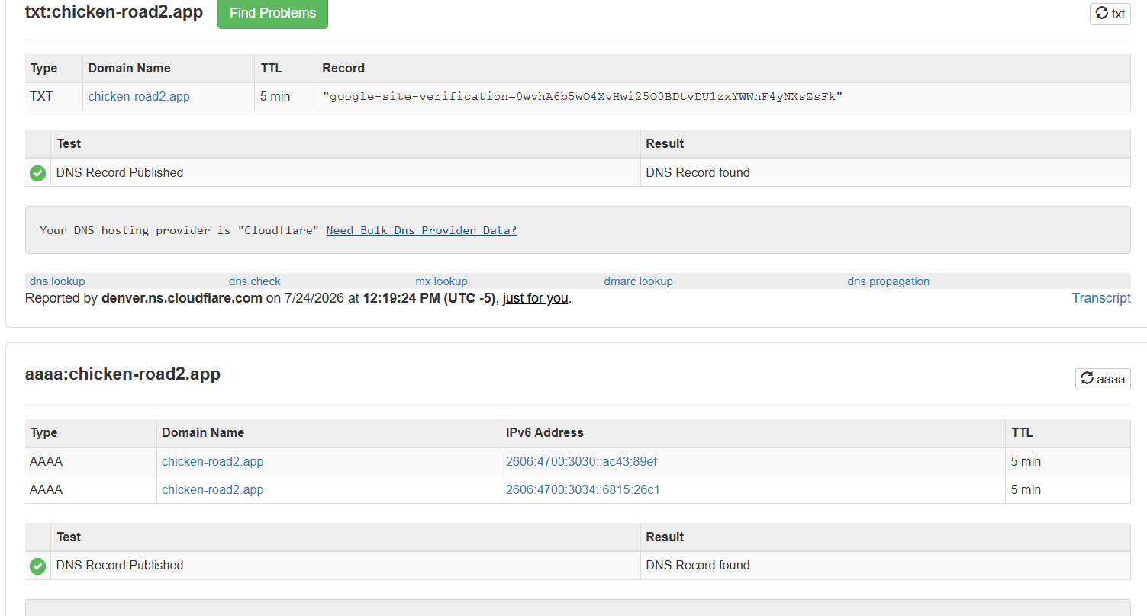

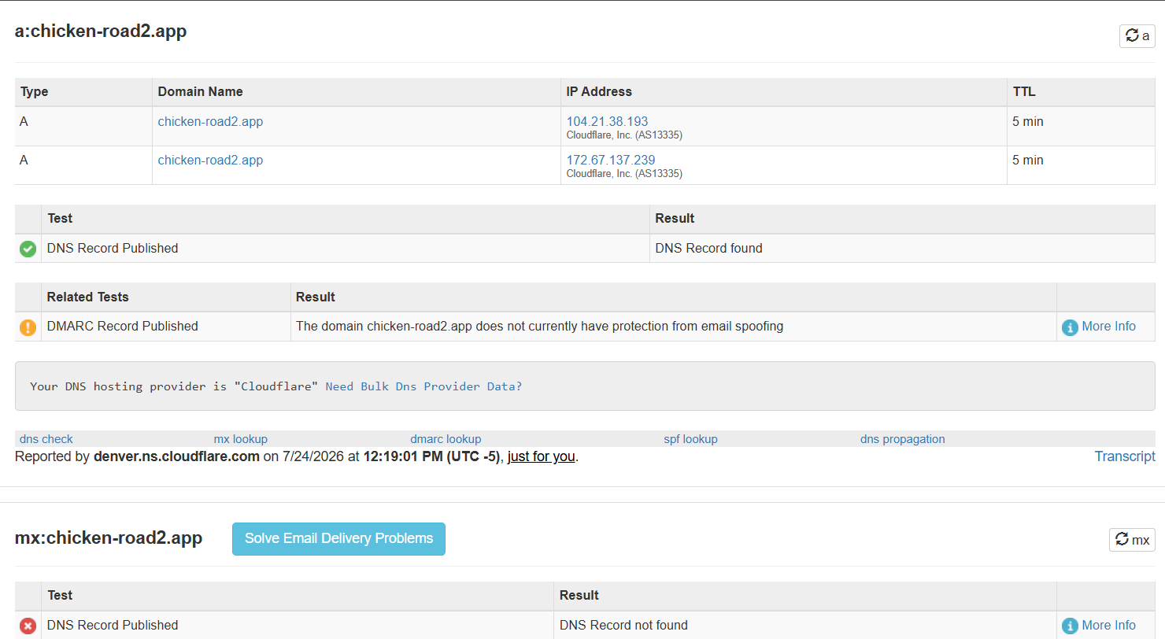
Figure 4 - IP Address Information
Screenshot showing the public IP address details, ASN, hosting network, and geolocation of the target domain.
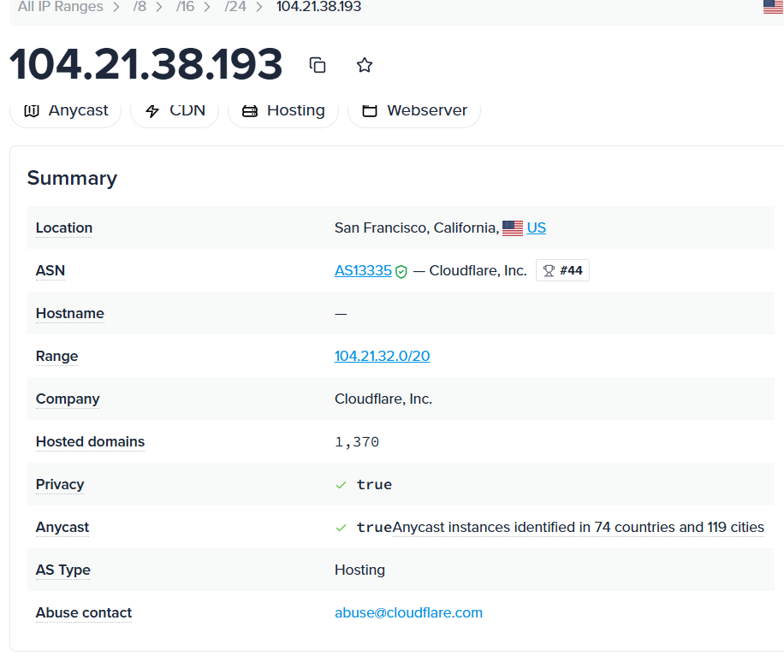
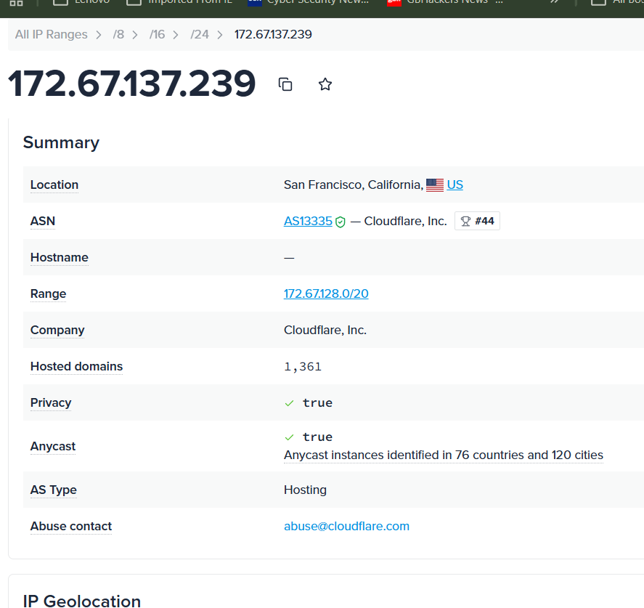

Figure 5 - Hosting Provider
Screenshot showing the hosting provider, ASN, and network infrastructure associated with the target website.
Same as IP Address Information

Figure 6 - SSL Certificate Information
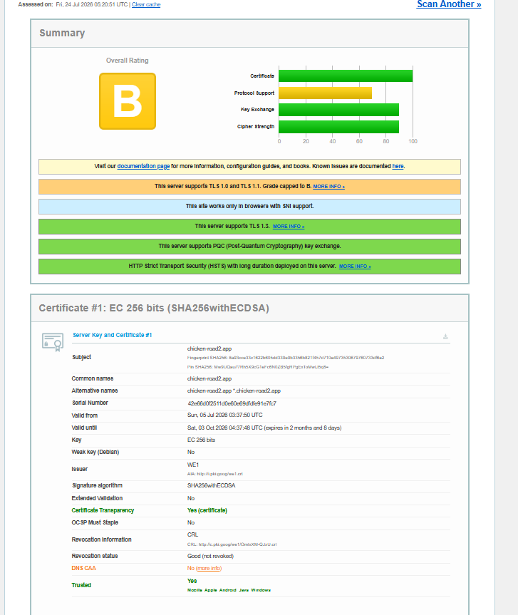
Screenshot showing the SSL/TLS certificate details, issuer, validity period, and trust status.
Figure 7 - Security Headers
Screenshot showing the implemented and missing HTTP security headers identified during the security assessment.
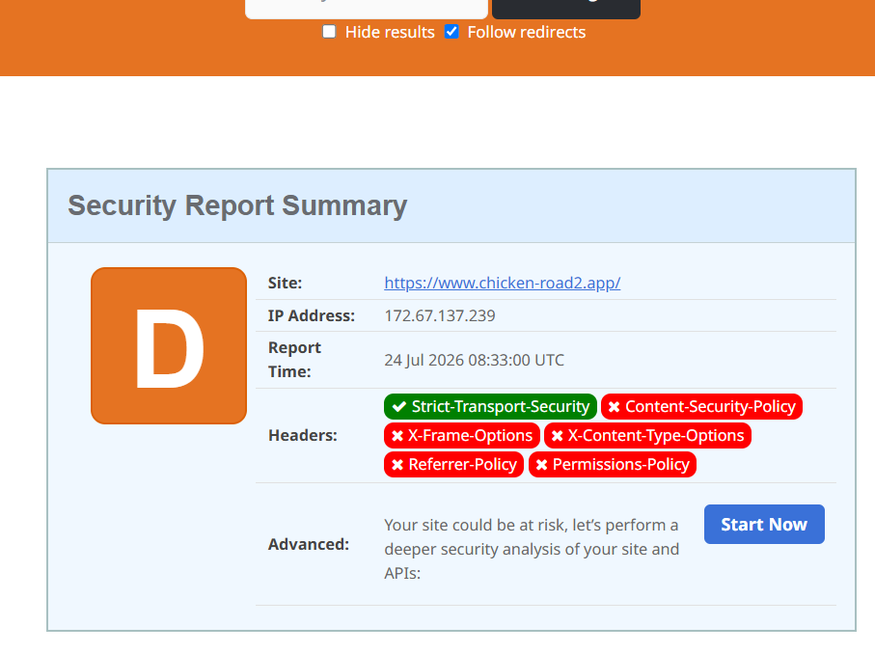

Figure 8 - Technologies Used
Screenshot showing the publicly identified technologies, frameworks, and services used by the target website.
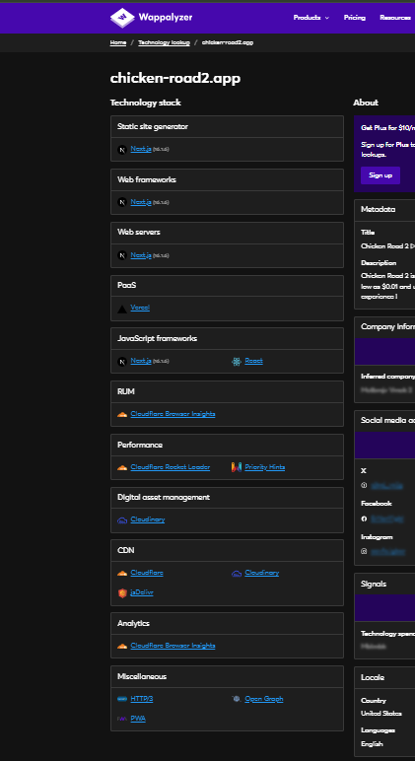

Figure 9 - Subdomains
Screenshot showing the publicly discoverable subdomains identified during the passive OSINT investigation.
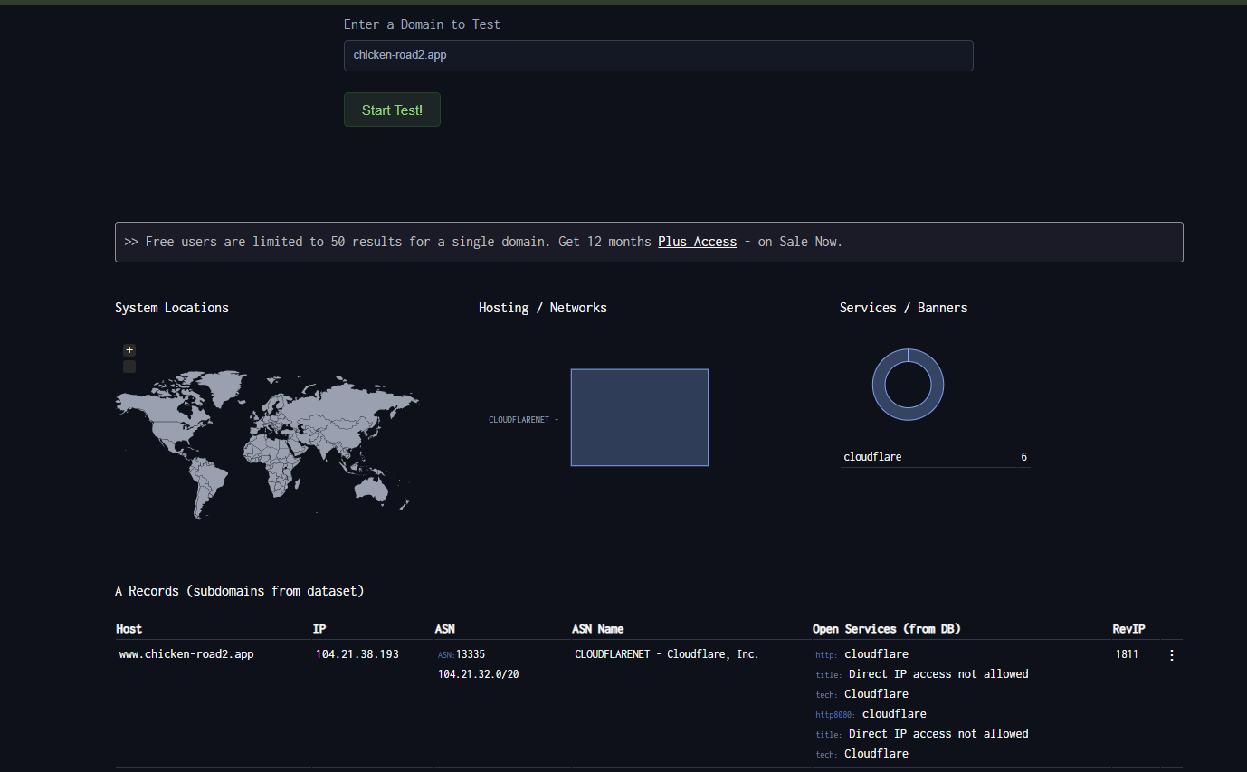
Figure 10 - robots.txt
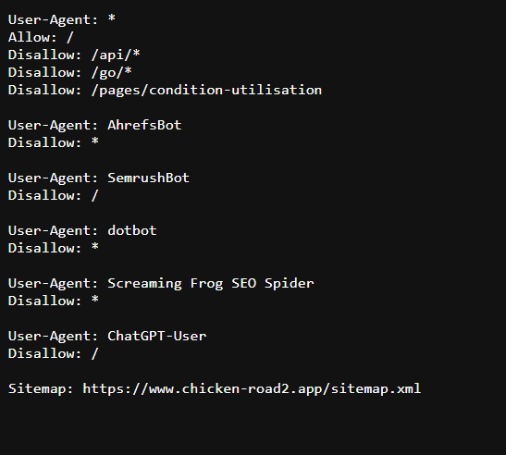
Screenshot showing the website’s robots.txt file, including crawler directives and sitemap location.
Figure 11 - sitemap.xml
Screenshot showing the website’s sitemap.xml file and its publicly indexed URL(s).

